**UI RESULTS**

1. Run the code and then go to <http://localhost:5000>, where you can access the web page like below:

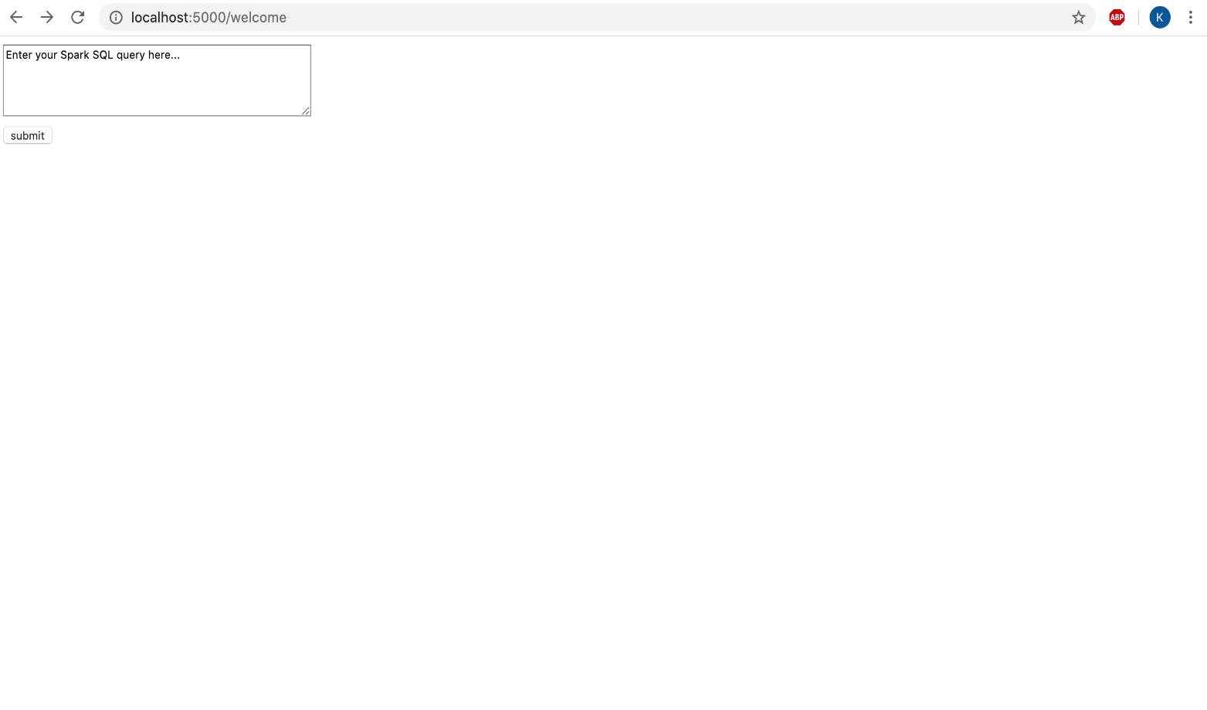

1. Enter the required query in the text area and click submit.

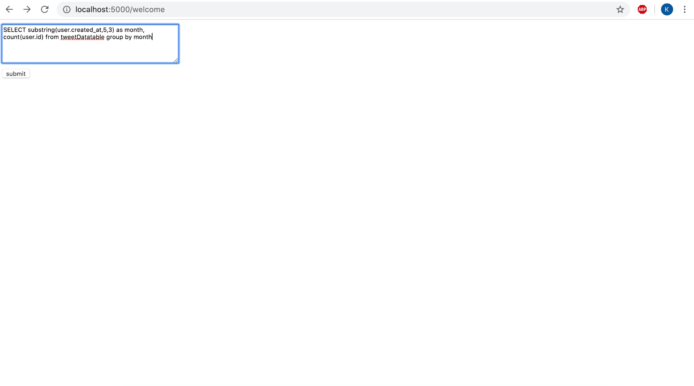

1. Now you can view the result of the query like below: 